**Lab How to use Get, Post, Patch, and Delete on Postman**

**Open Postman**.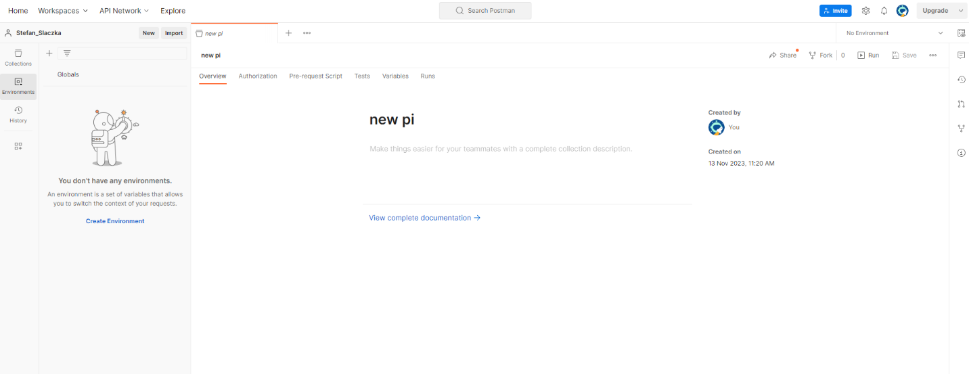

**Press the plus button**.



**Ensure the request type is GET. Copy and paste the following URL into the address bar:** [**https://group-9-api.vercel.app/student/**](https://group-9-api.vercel.app/student/)**. Then, press 'Send' to obtain the output**.A screenshot of a computer

**Add "12" at the end of the URL:** [**https://group-9-api.vercel.app/student/12**](https://group-9-api.vercel.app/student/12)**, and you should see a JSON object that represents the information for the student with the ID 12.**

Top of Form

**Click on "Save," then proceed to click on "New Collaboration." Name it "all," then click "Create," and finally, hit "Save." If done correctly, you should see the expected result.**

Press the plus button.



**Make sure the request type to "POST" and put the URL** [**https://group-9-api.vercel.app/student/create**](https://group-9-api.vercel.app/student/create/)**. POST creates something new and it goes in the API.**

**Select body, raw, and then change text to JSON. Finally Provide this JSON and click send.**

{

    "parameter": {

        "fname": "Zach",

        "lname" : "Walker"

    }

}

**If done right the output should look like this**

**Click save to make sure it is in the same collection and then hit save.**

**If done right, it should look like this.**

**Press the plus button.**



**Set the request type to PATCH.**

**Enter the URL provided for the PATCH request.** [**https://group-9-api.vercel.app/student/update/**](https://group-9-api.vercel.app/student/update/)

**Select body, raw, and then change text to JSON. Finally Provide this JSON.**

**Then go to the request type GET that we made and hit send. Then pick an object you want to change and put it in the id in the object below. Then add the object. And press send.**

{

    "parameter": {

        "id"  “your_selected_id” ,

        "fname": "Anthony D.",

        "lname" : "Epps"

    }

}

**Click save and make sure it is in the same collection.**

**Press the plus button.**



**Make sure the request type is DELETE. Then go to the request type GET that we made and hit send. Then pick an object you want to delete. And the id to the end of the link and press send.** [**https://group-9-api.vercel.app/student/**](https://group-9-api.vercel.app/student/)

**Save the file and click on all collection then click on the runs tab,**

**Then press run all.**

**click on Get, Post, Patch, and Delete. We can see in one run we can see all the outputs.**